**CS 457 Project #5 – The Giraffe Poster**

**By**: Rick Menzel  **Email**: [menzelr@oregonstate.edu](mailto:menzelr@oregonstate.edu)

**Screenshot(s)**:

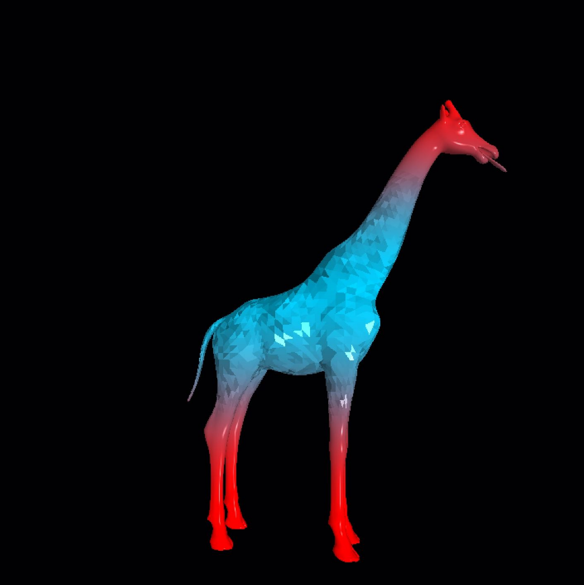

Fig 1. The Candied Giraffe

**Link**:

<https://media.oregonstate.edu/media/t/0_ycnm1ykv>

**Description**:

This giraffe uses a full lighting model with adjustable Ambient, Diffuse and Specular components, as well as adjustable shininess, turned up here to highlight the “cherry candy” extremities. The color gradations are achieved using the smoothstep() and mix() functions queueing off the absolute values of the y-coordinates. The flat shading used for the crystalline “rock-candy” body is similarly constrained to a band by y-coordinates. Notably, it is not the fragment coordinates that are used for this determination, but rather the polygon’s center as calculated within the geometry shader. Lastly, the normal within the blue area are adjusted using noise to create a sense of irregularities as one might expect in a confection.